SCHSL Spectator/ Facility Requirements for Venue Use

The purpose of this document is to provide South Carolina High School League member schools an outline of requirements for hosting an athletic contest where spectators will be attending. This document will apply if attendance at a venue exceeds the Governors Executive Order for spectator capacity (50% capacity or 250 persons at the venue whichever comes first). All member schools should refer to the CDC (www.cdc.gov) and SCDHEC (www.scdhec.gov) for additional information on best practices for managing events with groups of people.

General Guidelines:

Staying Home When Appropriate
- All staff, spectators and other auxiliary groups should stay home if they have a fever or feel sick.
- All staff, spectators and other auxiliary groups must quarantine and stay home if they have tested positive for COVID-19 or are showing COVID-19 symptoms.
- All staff, spectators and other auxiliary groups must quarantine and stay home and monitor their health if they have had close contact with a person who has symptoms of COVID-19 within the past 14 days.
Capacity of Venue:

- Schools should determine what capacity their venue can accommodate so that people remain 6 feet apart at all times. (Indoor facilities should not exceed 50% capacity as defined by the Fire Marshall).
- Schools may include standing room only and non-traditional seating areas in their capacity accommodations
- When determining capacity, consideration must be given to seating occupied by media, teams in waiting, or any other group that will have seating blocked off for their use during the event.
- Signage should be posted to indicate the capacity of your venue.
- Venue policies such as restricted use of playgrounds and other open areas where children have traditionally played during athletic contests will require home management to plan to supervise and/or restrict these areas from use.
- Establish a plan and protocol for when your venue reaches capacity. This plan should be in place before holding an event. Communicate your plan with all event workers and visiting schools.
- Once you have reached capacity no other persons should enter the venue.

Personal Safety Requirements:

- All staff, spectators and anyone associated with an auxiliary group must wear a face covering at all times.
- All spectators and anyone associated with an auxiliary group must maintain 6 feet social distancing at all times during the event. (Consideration should be given to families from the same household)
- Megaphones and any other similar artificial noisemakers that could potentially spread respiratory droplets are prohibited for use by spectators.
- Schools and Districts should revise their Emergency Action Plans as needed to address social distancing in the event there is an emergency procedure needed during a contest.
- Host Schools should consider having a COVID-19 coordinator that lays out a specific plan on how to deal with someone who becomes ill during the contest that minimizes their contact with others in attendance.

Cleaning and Disinfecting:

- Clean and disinfect frequently touched surfaces within the venue at least daily and between uses as much as possible—for example, door handles, sink handles, grab bars, hand railings, and cash registers.
- Clean and disinfect shared objects between uses—for example, payment terminals, tables, countertops, and condiment holders.
- High use areas such as restrooms, ticket counters, and concession windows should be cleaned frequently throughout the event.
- Consider closing areas that cannot be adequately cleaned and disinfected during an event.
- Develop a schedule for increased routine cleaning and disinfection.
- Set up hand sanitizer stations at ticket windows, gate entrances, restrooms and throughout the venue.

Physical Barriers and Guides:
- Provide physical guides, such as placards, tape on floors or sidewalks and signs on walls, to ensure that individuals remain at least 6 feet apart in lines and at other times (e.g., guides for creating one-way routes).
- Install physical barriers, such as sneeze guards and partitions, in areas where it is difficult for individuals to remain at least 6 feet apart. Barriers can be useful at cash registers and other areas where maintaining physical distance of 6 feet is difficult.
- Block off seats on each row that are closest to the steps to allow for 6 ft. social distancing during traffic flow.
- Change seating layout or availability of seating so that people can remain least 6 feet apart.

Communication, Signs and Messages
- Schools must communicate clear expectations and any relevant city, county and district ordinances with visiting schools that are specific to your venue.
- Post signs in highly visible locations (e.g., at entrances, in restrooms) that promote everyday protective measures and describe how to stop the spread of germs by properly washing hands and properly wearing a mask. (Find freely available CDC print and digital resources about COVID-19 on CDC’s communications resources main page.)
- Post signs that communicate the risk of attending the event as it relates to spreading and contracting COVID-19.
- Utilize PA systems to broadcast regular announcements on reducing the spread of COVID-19 on public address systems.
- Utilize social media to spread information about behaviors that prevent spread of COVID-19.
- Utilize social media to share information about your venue to potential spectators

Restrooms
- Consider limiting the number of people who occupy the restroom at one time to allow for social distancing. Signs should be posted outside the restroom to display the maximum capacity while maintaining social distancing.
- Do not allow lines or crowds to form near the restroom without maintaining a distance of at least 6 feet from other people. It may be helpful to post signs or markers to help attendees maintain the appropriate social distance of at least 6 feet.
- Ensure that open restrooms are:
  - Operational with functional toilets.
  - Cleaned and disinfected regularly, particularly high-touch surfaces such as faucets, toilets, stall doors, doorknobs, countertops, diaper changing tables, and light switches.
    - Clean and disinfect restrooms daily or more often, if possible, with EPA-approved disinfectants against COVID-19.
    - Ensure safe and correct application of disinfectants and keep products away from children.
  - Adequately stocked with supplies for handwashing, including soap and water or hand sanitizer with at least 60% alcohol (for staff and older children who can safely use hand sanitizer), paper towels, tissues, and no-touch trash cans.
    - If you are providing portable toilets, also provide portable handwashing stations and ensure that they remain stocked throughout the duration of the event. If possible, provide hand sanitizer stations that are touch-free.

Concessions
- If the event includes food service, refer to CDC’s COVID-19 considerations for restaurants and bars.
- Use touchless payment options as much as possible, if available.
- Ask customers and employees to exchange cash or card payments by placing them on a receipt tray or on the counter rather than by hand to avoid direct hand-to-hand contact.
- Clean and disinfect frequently touched surfaces such as pens, counters, or hard surfaces between use and encourage patrons to use their own pens.
- Provide physical guides, such as tape on floors or sidewalks and signs on walls, to ensure that individuals remain at least 6 feet apart when waiting in line to order or pick up.
- If possible, concessions should be available to both home and away spectators without the groups crossing over.
- If possible, satellite concession stands should be set up to allow spectators more options to purchase while minimizing the length of lines.
- Only pre-packaged drinks and foods may be sold.
- Use disposable food service items including utensils and dishes. If disposable items are not feasible or desirable, ensure that all non-disposable food service items are handled with gloves and washed with dish soap and hot water or in a dishwasher.
- Individuals should wash their hands after removing their gloves or after directly handling used food service items.
- Only pre-packaged condiments may be used.

Pre-event/ Spectator Arrival and Entrance:
Parking:
- If possible, communities should be separated for parking.
- Gathering of crowds for tailgating or other social interactions is prohibited.
- Upon exiting the vehicle, all persons must put on their face covering.

Ticket Sales:
- E-tickets and pre-sale options should be used to avoid long lines the night of an event. These options should be made available to visiting schools.
- If possible, tickets should be sold in a “drive-through” manner where each car will purchase tickets for everyone in the car to prevent standing in lines.
- If possible, home and visiting spectators should have separate ticket booths to purchase tickets.
- If separate ticket booths are not possible, physical barriers should be used to help keep communities separate.
- Provide physical guides, such as placards, tape on floors or sidewalks and signs on walls, to ensure that individuals remain at least 6 feet apart when waiting in line.
- Use touchless payment options as much as possible, if available.
- Exact change should be used if possible to prevent money from having to be exchanged.
- Customers and employees should exchange, tickets, cash or card payments by placing them on a receipt tray or on the counter rather than by hand to avoid direct hand-to-hand contact.
- Clean and disinfect frequently touched surfaces such as pens, counters, or hard surfaces between use and encourage patrons to use their own pens.
- Hand Sanitizer should be available at every ticket window.
Spectator Flow:
- Hand sanitizer stations should be set up at all entrances and exits.
- Consider unidirectional foot traffic flow- entering one portal or door and exiting through another.
- If possible, separate entrance gates for home and visiting spectators should be used.
- If possible, separate exit gates for home and visiting spectators should be used.
- Provide physical guides, such as placards, tape on floors or sidewalks and signs on walls, to ensure that individuals remain at least 6 feet apart when waiting in line to enter or exit a facility.
- Spectators should not be able to cross from one side of a venue to the other during the contest to limit communities from interaction.
- If possible, multiple exits should be used post-event to allow for spectators to maintain social distancing while exiting the facility.
- Congregating in groups inside a venue is not allowed. Any area that cannot be monitored to ensure social distancing can be maintained should be a restricted area.
Post Event:
- Utilize PA announcements prior to the end of an event to remind all spectators to remain off the field/court once the event is over.
- Utilize PA announcements prior to the end of an event to remind spectators to practice social distancing when the contest is over.
- Spectators, including parents, should not be allowed to visit with any athlete in the facility once the contest is over to prevent congregating and large group gathering.
- Schools should designate a “pick up area” for those needing a ride so they do not congregate directly outside the exits. This pick-up area should allow for social distancing.

Specific Venue Guidelines for Spring Sports
In addition to the above requirements, the following requirements will be used for hosting individual sports.

Tennis Facilities:

- Spectators will not be allowed to sit inside or on the courts unless there is a physical barrier between the spectators and players. (In Yellow below)
- Spectators must remain behind the physical barrier at all times. (In Yellow below)
- If a physical barrier is not present, then spectators must remain at minimum 10 ft from the nearest edge of the court surface. (In Yellow below)
- Spectators who use personal chairs must remain 6ft apart at all times.
- Schools should designate a section for each team to sit that will only include members of the team and/or coaches and staff. ( In Red below)

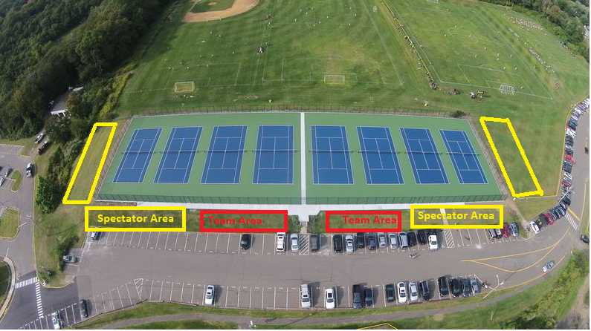

Golf Course:

- Local course restrictions for COVID-19 will apply.
- Schools should communicate any course requirements for spectators and participants and with all competing schools and coaches.
- Spectators should remain on the cart path or as close to the cart path as possible at all times while maintaining social distancing.
- Post-match awards ceremonies should be posted at a later time or held virtually.

Stadiums:

Soccer and Lacrosse Considerations
- Spectators must remain in spectator seating areas at all times. (In Blue below)
- Sidelines should be limited to essential personnel only.
- Gathering of teams post-game should not be allowed.
- Designate area for teams waiting to play in the bleachers that is away from spectators. (In Red below)
- If personal chairs are allowed along fence lines, ensure that other spectators to include stading room only are at minimum 6ft apart

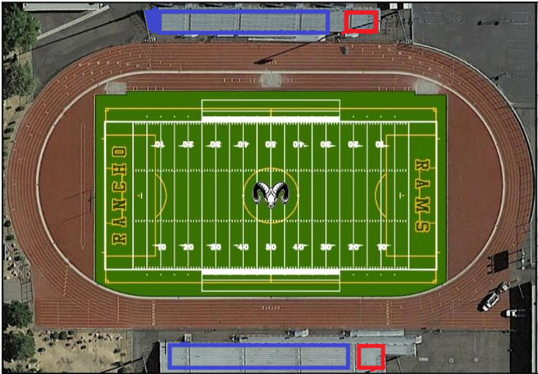

Track Considerations:
- Designate one side of venue for spectator seating (In Red below)
- Designate one side of the venue for teams to sit in between events. (In Green below)
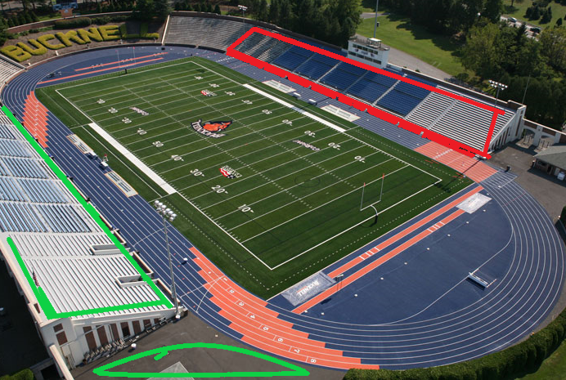

Baseball/ Softball Considerations:
- Spectators must remain behind the physical barrier (fence, net, etc) at all times. (In Yellow below)
- If a physical barrier is not present, then spectators must remain at minimum 10 ft from the nearest dead ball area line.
- Spectators who use personal chairs must maintain 6ft apart at all times.
- Designate area for standing room only. (In Yellow below)
- Designate an area for teams who are waiting to play. (In Black below)
- Standing room spectators should maintain 6ft social distancing at all times.
- If concession stands are near bleachers or spectator seating, schools should ensure that there is 6ft social distancing between spectators and those purchasing from the concession stand.
- If dugouts do not have a solid wall that separates players from spectators, create a minimum of 6ft from the dugouts to the nearest spectator seating area to ensure social distancing.
Examples of spectator seating options shown in yellow. Examples of where teams who are waiting to play are shown in black. IF the area beyond the outfield fence allows, spectators could use that area as well.
