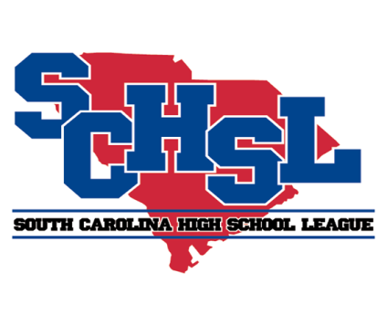 | South Carolina High School League  PO Box 211575  Columbia, SC 29221-6575  803-798-0120  www.schsl.org

NOTIFICATION OF ENTRY FOR COMPETITIVE CHEER

(Due on or before OCTOBER 20, 2017) (e-mail to jan@schsl.org)

SCHOOL

Classes AAAAA, AAAA & AAA (Select one below)

We will compete for the State Competitive Cheer Championship.

We will not compete for the State Competitive Cheer Championship.

Class AA & A (Select one below)

We will compete for the Class AAA State Competitive Cheer Championship.

We will enter the Class AA Invitational.

We will not compete.

Name of Cheer Coach:

Cheer Coach E-mail:

Cheer Coach Cell:

Person completing this report:

Date:

