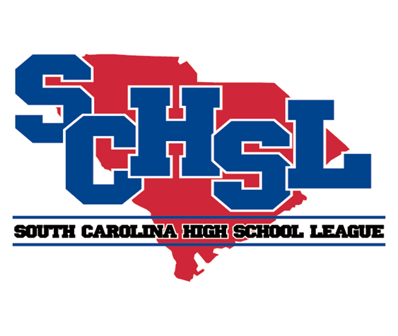 | South Carolina High School League  PO Box 211575  Columbia, SC 29221-6575  803-798-0120  www.schsl.org

Living Clean Litter Clean Up Report

High School:

Athletics Director’s Name:

Organized Through Palmetto Pride? |  | Yes |  | No

Number of Athletes taking part in this project:

Breakdown of Litter Clean Up Initiative Project: (Please use the following space to briefly explain your project and which teams participated.)

Project Name: |  | Date(s) of Project:

Brief Description:

________________________ __________________
Principals Signature Date

Please return by email to
Email: jan@schsl.org

