**Wednesday’s Schedule SCHSL Student Leadership Summit**

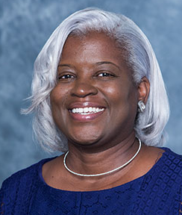

**9:00 am Welcome**

**9:05 am Opening Remarks**

**9:10 am Introductions**

**9:15 am Leadership Workshop**

**11:15 pm Closing Session**

**11:20 pm SCHSL Promotions Dr. Yasha Jones Becton**

**Thursday’s Schedule SCHSL Student Leadership Summit**

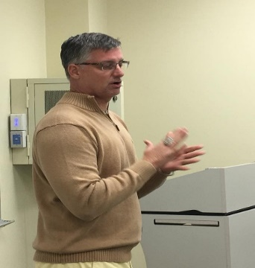

**11:00 am Welcome**

**11:05 am Opening Remarks**

**11:10 am Introductions**

**11:15 am Sportsmanship Workshop**

**12:15 pm Closing Session**

**12:20 pm SCHSL Promotions Coach Andy Hallett**

**Friday’s Schedule SCHSL Student Leadership Summit**

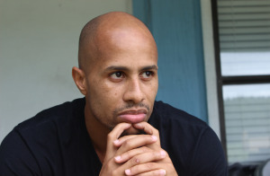**1:00 pm Welcome**

**1:05 pm Opening Remarks**

**1:10 pm Introductions**

**1:15pam S C O R E Workshop**

**2:15 pm Closing Session**

**2:20 pm SCHSL Promotions Mr. Kyle A. Greene**