2021 June Scholastic Basketball Showcase

Boys Team Event Information and Registration:
Date: June 18-19
Location: Rock Hill Sports and Events Center
- All Schools must participate in one of the NCAA Educational Meeting
- Schools must provide their own basketballs for competition.
- Questions email schoopcoaches@gmail.com
Doors Open: 1 hour prior to first tip each day.

Boys/Girls Individual Camp
Date: June 20
Location: Rock Hill Sports and Events Center
Check in: 8:30 am – 9:00 am
- Questions email schoopcoaches@gmail.com

Ticketing Information
Admission: $10 per person per day.
Tickets Can ONLY be purchased at www.gofan.com
*Tickets will not be available at the door*
Spectator and Bus Parking Map
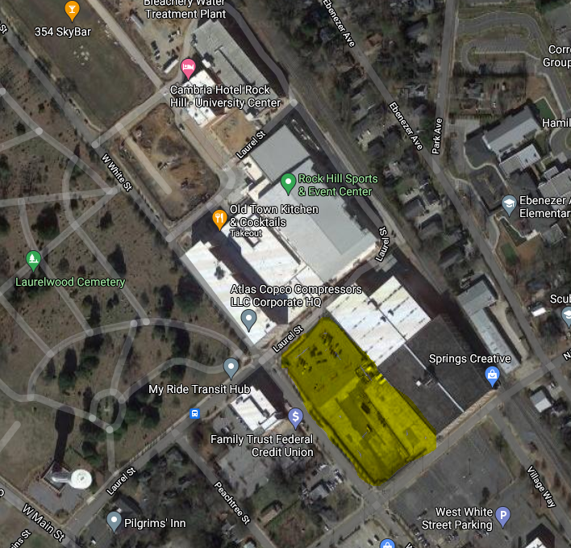
Deck A - Spectator parking

Bus Parking
Rock Hill Sports & Event Center
Bus Parking: Follow red arrows pull in off West White street use address 220 W White Street Rock Hill 29730
HS Player and Coach Entrance – Please follow the yellow arrows and enter through back hallway. Team registration will be in this hallway which leads directly to playing area. There will be signs.
Spectator parking: please park in Deck A 348 Technology Center Way Rock Hill SC 39730.
Face Coverings are encouraged for all and all persons will have a temperature screening upon entry.
Spectators must remain in the spectator area at all times.

